Name : Rajvardhan Reddy
Reg No : 180905093
Sec : B
Roll No : 19

OS LAB – 1: Working with Regular Files

Sample program :

#include <stdio.h>
#include <stdlib.h>
#include <sys/stat.h>
#include <fcntl.h>
#include <stdlib.h>

int main()
{
char c;
int in, out;
char buffer[128];
int nread;
in=open("sample.txt",O_RDWR);
nread=read(in,buffer,128);
printf("File Content is : %sand Number of characters are = %d\n",buffer, nread);
exit(0);
}

Output :

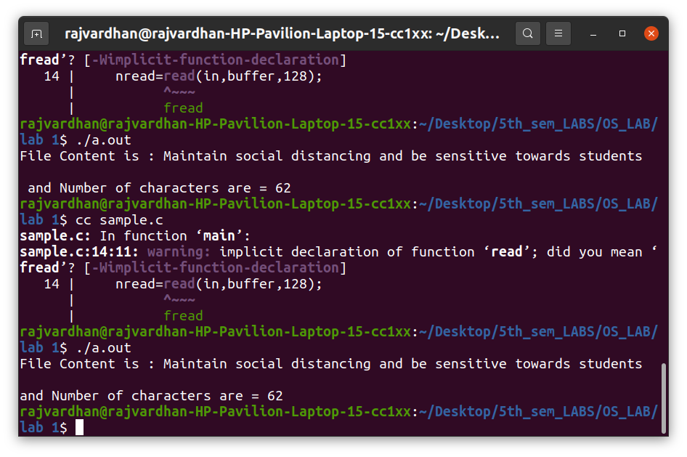

P1) Write a program to print the lines of a file that contain a word given as the program argument (a simple version of grep UNIX utility)

program :

#include <stdio.h>
#include <unistd.h>
#include <sys/stat.h>
#include <fcntl.h>
#include <stdlib.h>
#include <string.h>

int main(int argc, char *argv[])
{

int sfd,i=0,k=0;
char ch[100],chr;

if(argc!=3)
{
printf("Insufficient Arguments\n");
exit(1);
}

if( (sfd=open(argv[2],O_RDONLY))==-1)
{
printf("File not found\n");
exit(1);
}

// printf("File Contents=%s and Number of characters are=%d",buffer, nread);
while((read(sfd,&chr,1))>0)
{
if(chr!='\n')
{
ch[i]=chr;
i++;

}

else
{
k++;
ch[i]='\0';
i=0;
if(strstr(ch,argv[1])!=NULL){
printf("Line:%d \t %s \n", k,ch);
}
}
}

exit(0);

}

Output :

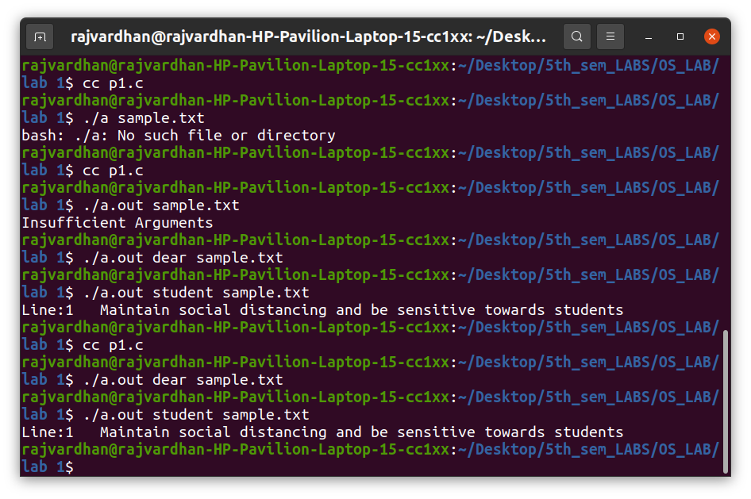

P2) Write a program to list the files given as arguments, stopping every 20 lines until a key is hit. (a simple version of more UNIX utility)

program :

#include <stdio.h>
#include <unistd.h>
#include <sys/stat.h>
#include <fcntl.h>
#include <stdlib.h>
#include <string.h>

int main(int argc, char *argv[])
{

int sfd,sfd2,i=0,k=0,p=0;
char ch[100],ch2[100],chr;

if(argc!=3)
{
printf("Insufficient Arguments\n");
exit(1);
}

if( (sfd=open(argv[1],O_RDONLY))==-1)
{
printf("File not found\n");
exit(1);
}

// printf("File Contents=%s and Number of characters are=%d",buffer, nread);
while((read(sfd,&chr,1))>0)
{
if(chr!='\n')
{
ch[i]=chr;
i++;
}

else
{
k++;
p++;
ch[i]='\0';
i=0;
printf("Line:%d \t %s \n", p,ch);
if(k==20)
{
fgetc(stdin);
k=0;
}
}
}
close(sfd);

if( (sfd2=open(argv[2],O_RDONLY))==-1)
{
printf("File not found\n");
exit(1);
}

p=0;

while((read(sfd,&chr,1))>0)
{
if(chr!='\n')
{
ch2[i]=chr;
i++;
}

else
{
k++;
p++;
ch[i]='\0';
i=0;
printf("Line:%d \t %s \n", p,ch2);
if(k==20)
{
fgetc(stdin);
k=0;
}
}
}exit(0);
}

Output :

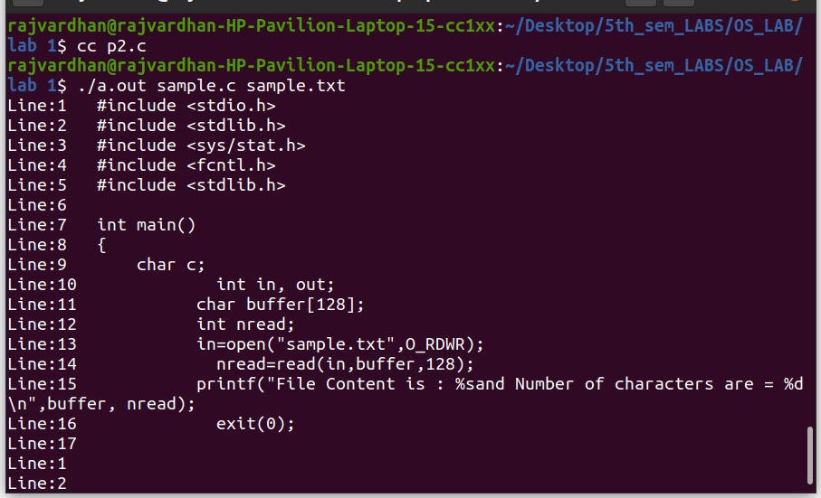

P3) Demonstrate the use of different conversion specifiers and resulting output to allow the items to be printed.

Program :

#include<stdio.h>
#include<stdlib.h>
#include<errno.h>
// extern int errno;

int main()
{
int a=81;
float b=9.1;
char c='p';
char str[]="OS Lab";
printf("a=%d b=%f c=%c str=%s hexadecimal for a=%x \n",a,b,c,str,a);
errno=EPERM;
printf("Error Access Errno= %m\n");
}

Output :

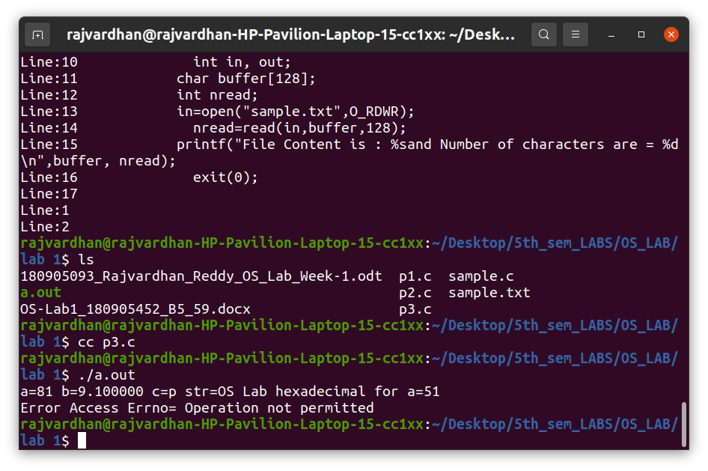

P4) Write a program to copy character-by character copy is accomplished using calls to the functions referenced in stdio.h.

program :

#include<stdio.h>
#include <unistd.h>
#include<sys/stat.h>
#include<fcntl.h>
#include<stdlib.h>

int main(int argc, char *argv[])
{

char c;
int in,out;
char buffer[128];
int nread;

if(argc!=3)
{
printf("Insufficient Arguments\n");
exit(1);
}

in=open(argv[1],O_RDWR);
out=open(argv[2],O_WRONLY|O_CREAT, S_IRUSR|S_IWUSR);

if( in==-1 || out==-1)
{
printf("File not found\n");
exit(1);
}

while(read(in,&c,1) == 1)
{
write(out,&c,1);
}

printf("Contents of file copied\n");
exit(0);

}

Output :

